1. Go to Anaconda websit to download the proper installation file, such as "Anaconda3-2019.03-Windows-x86_64.exe".

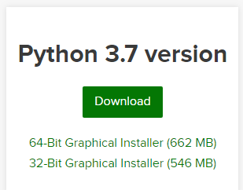

2. Then run the exe file to install Anaconda. Remember check the "Add Anaconda to the syste PATH enviroment variable' option.

3. This step is most important in the procedure.

1) We can directly use the command line to install tensorflow into our python environment, but there is one point we need to care about, which is use “activate base” command to specify that the installation is for Anaconda environment. Otherwise, we will install tensorflow for python IDLE.

After we activate base, we need to use the command “pip install tensorflow” to install it in our computer.

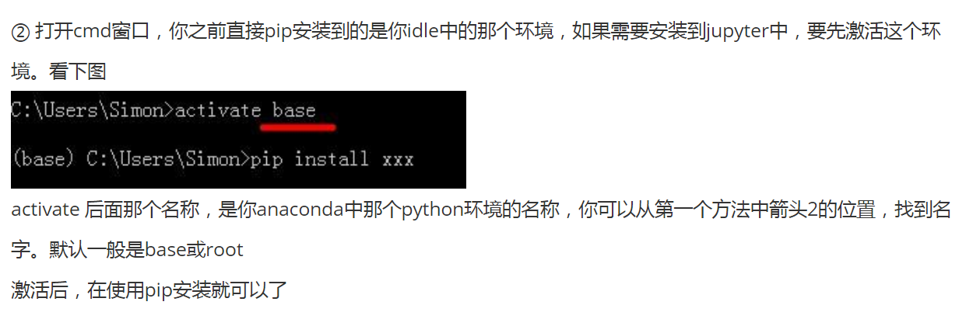

2) We could also use Anaconda Navigator to install tensorflow, see the picture blow.

